Project Description: EMPLOYEE DATABASE MANAGEMENT SYSTEM USING AWS RDS and EC2
Overview
Create a MySQL database was created using Amazon RDS (Relational Database Service). The database and its tables were managed remotely using a connected Amazon EC2 instance. The EC2 instance was accessed via SSH, and the MySQL client was installed on it to interact with the RDS database. A complete backup of the database was then taken using the mysqldump tool.

RDS Database Create
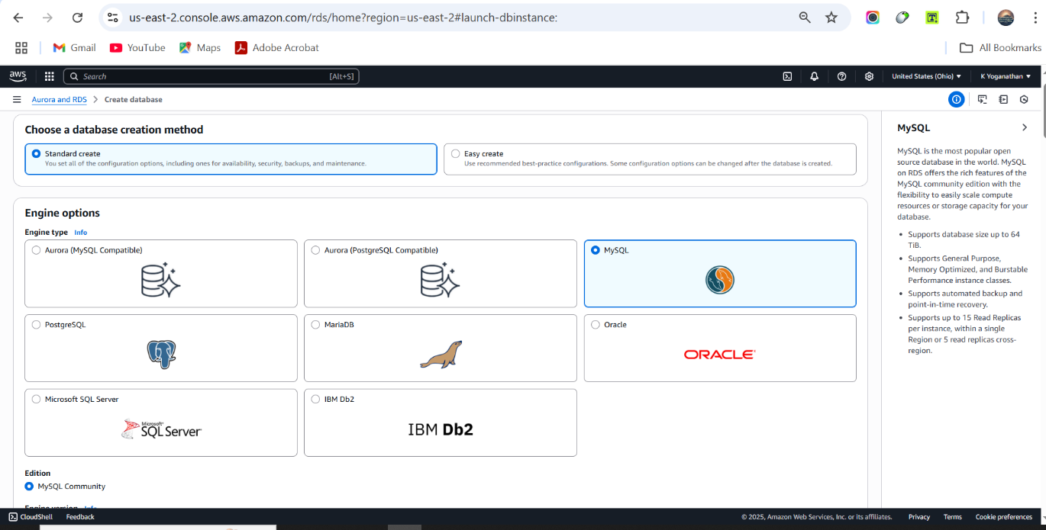

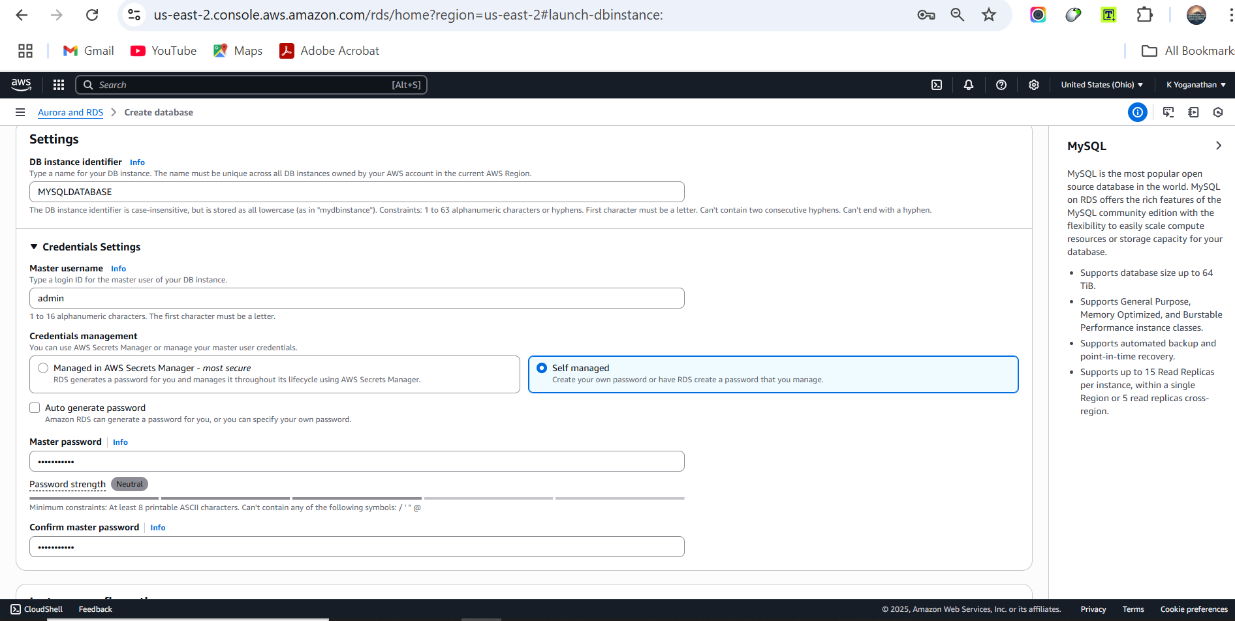

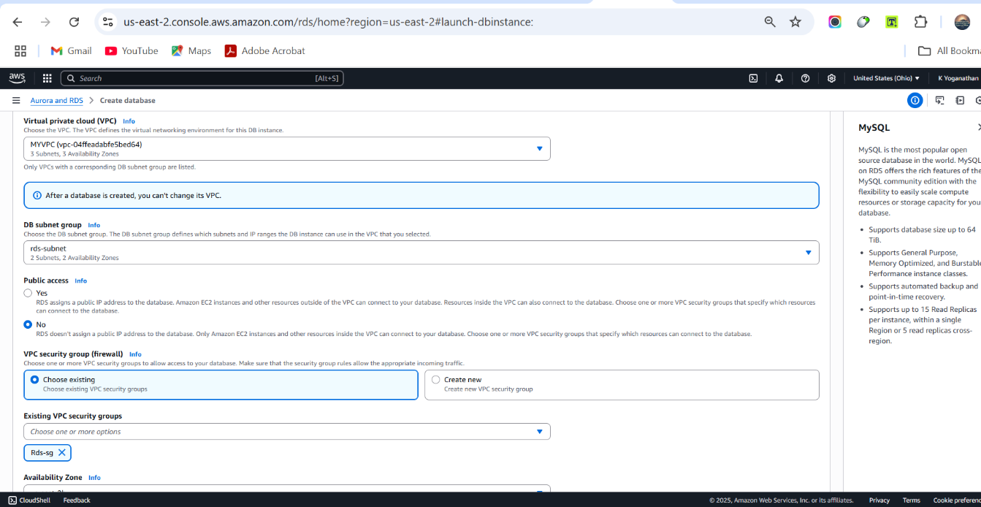

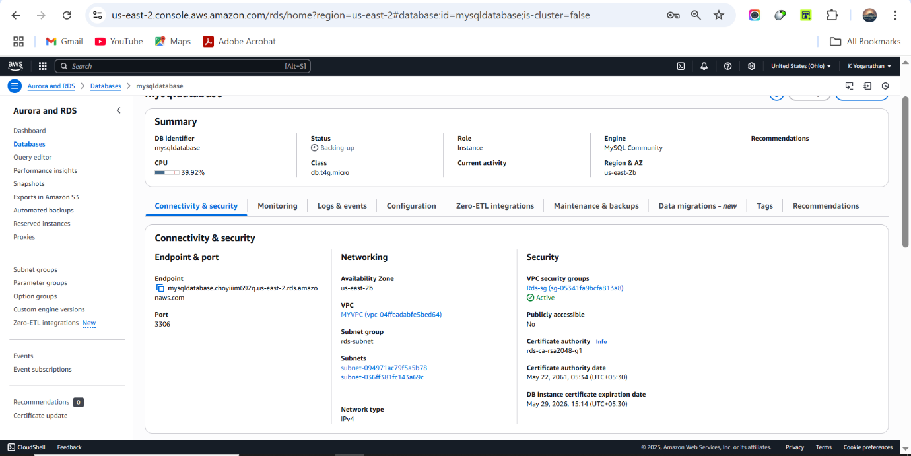

Launch Ec2 Instance
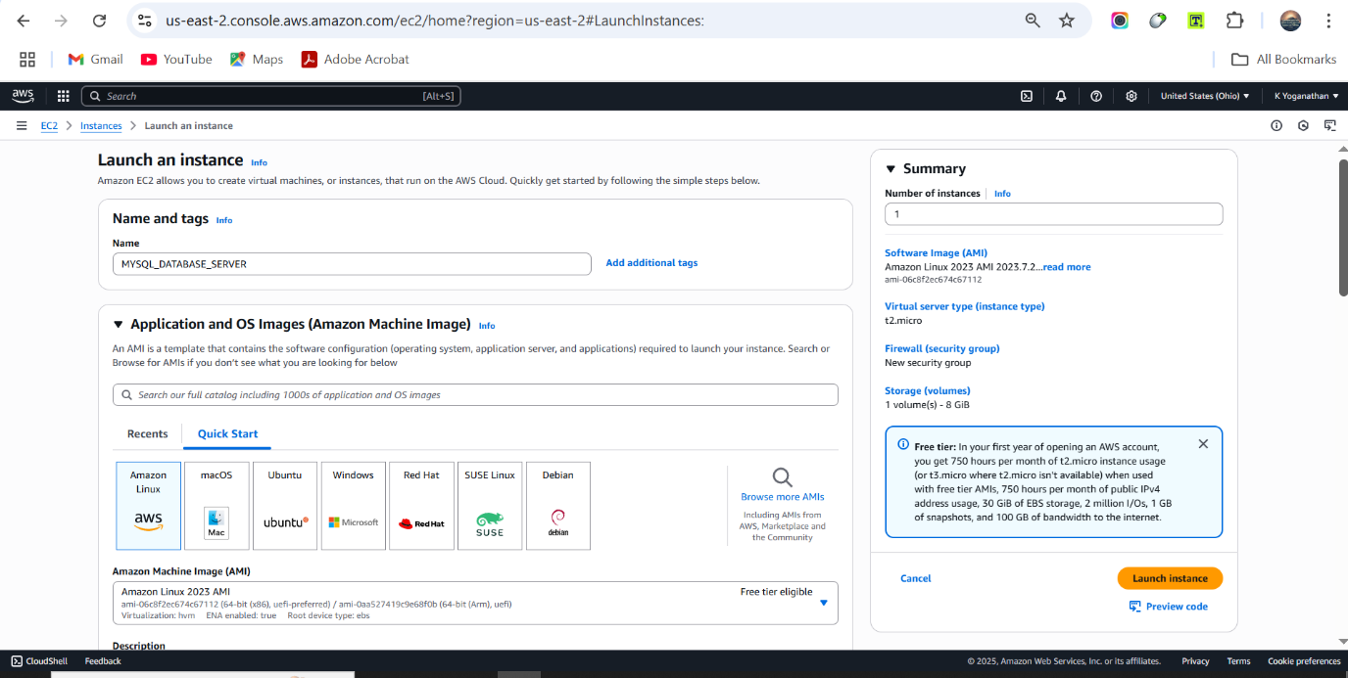
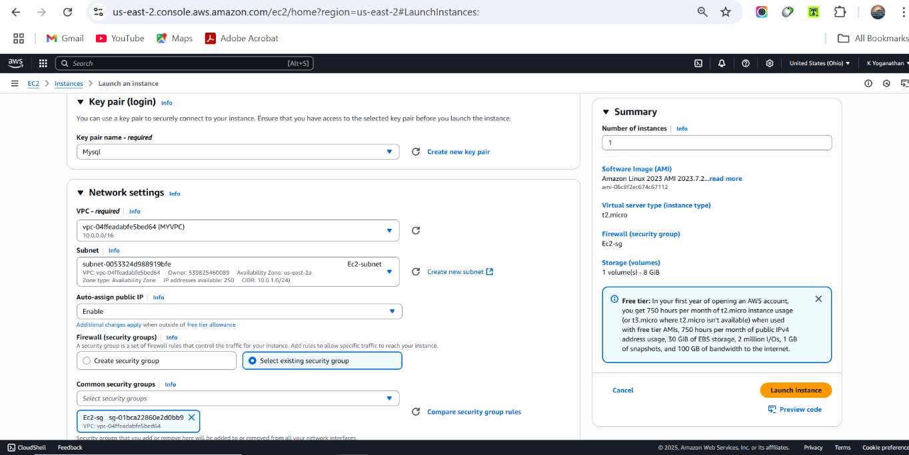
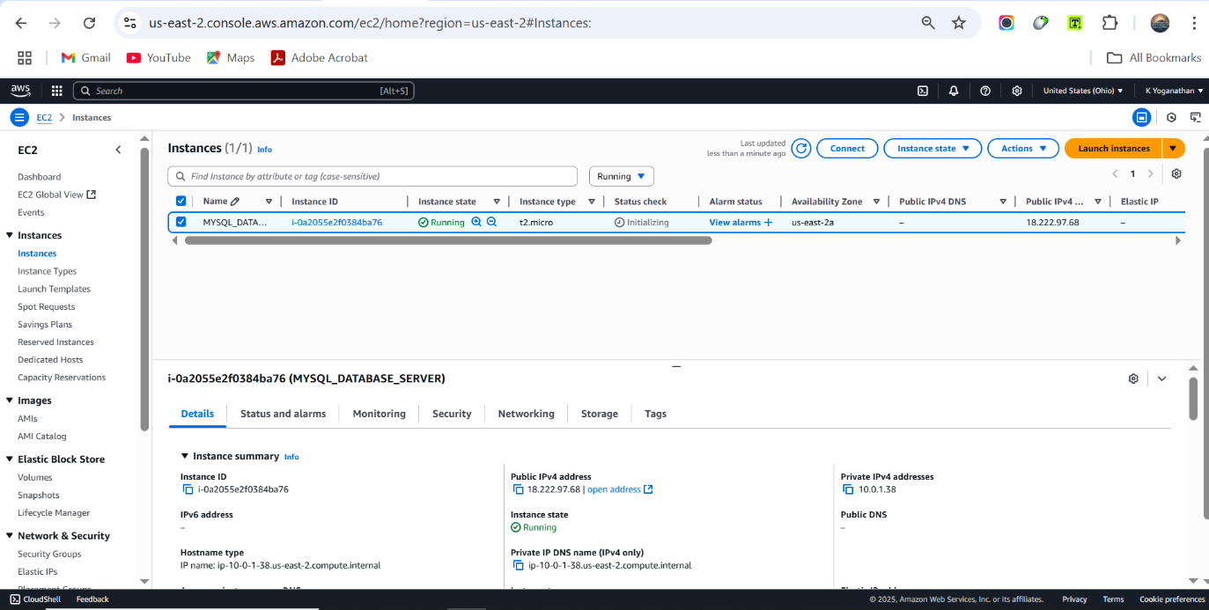
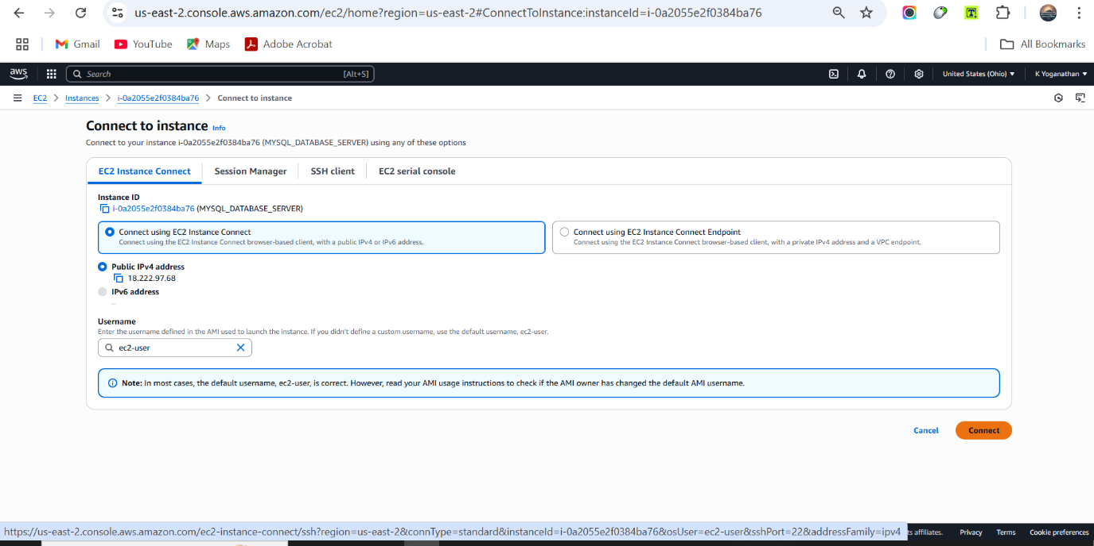
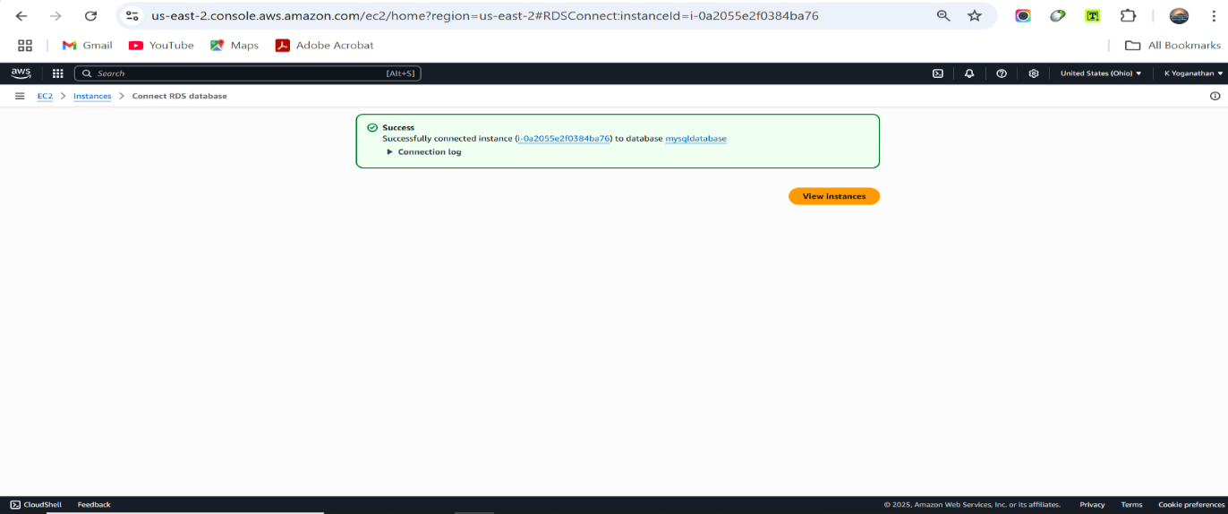
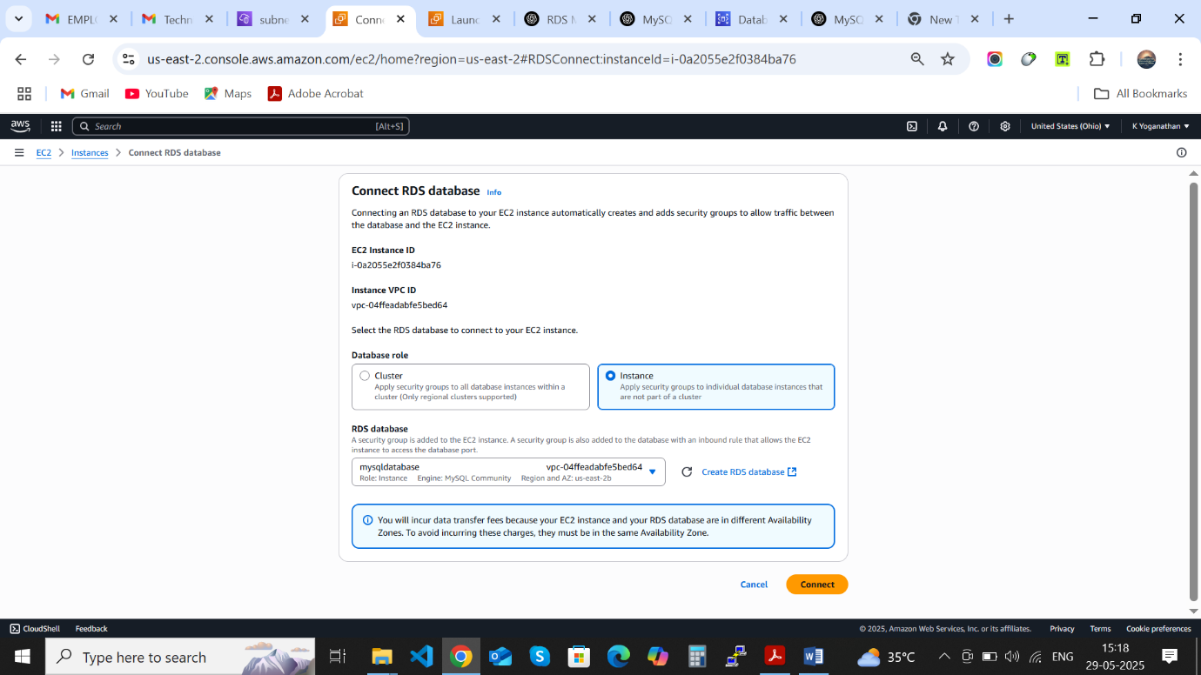
Connecting to EC2 and Accessing RDS MySQL via Endpoint

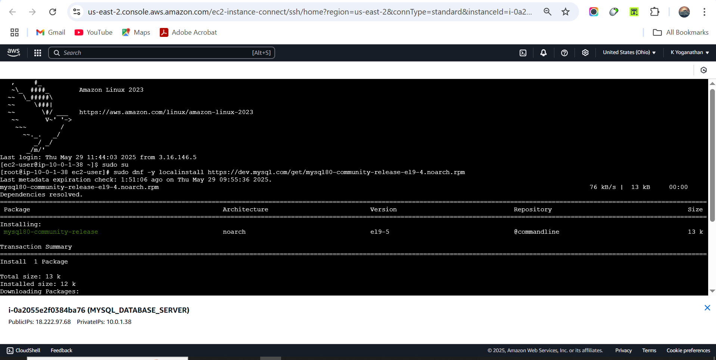
Connect to EC2 Instance via SSH

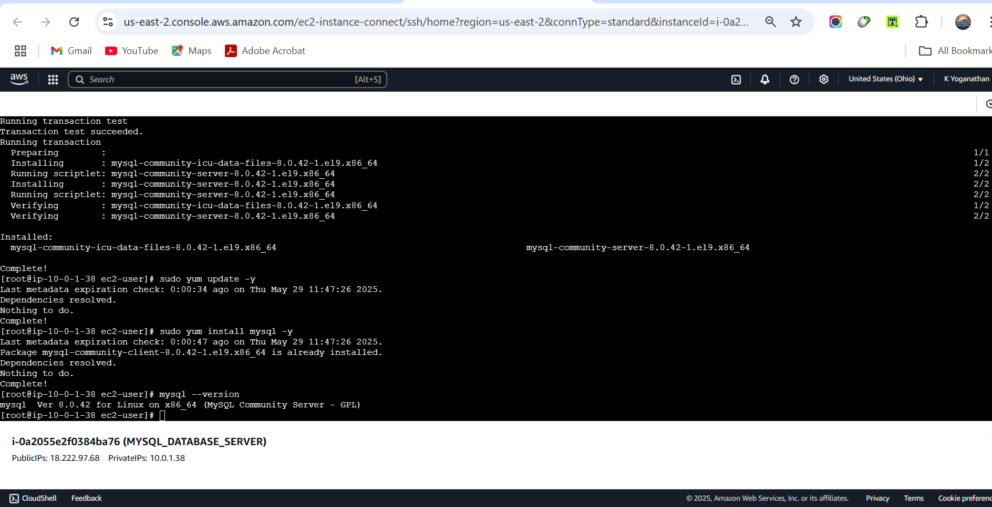
Install MySQL Server

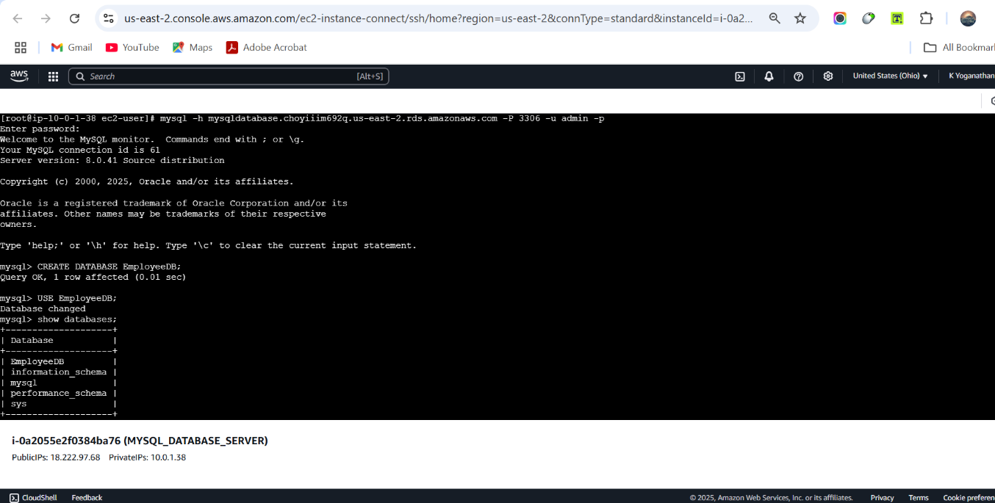
Connect to RDS MySQL Instance

Create a Database Table
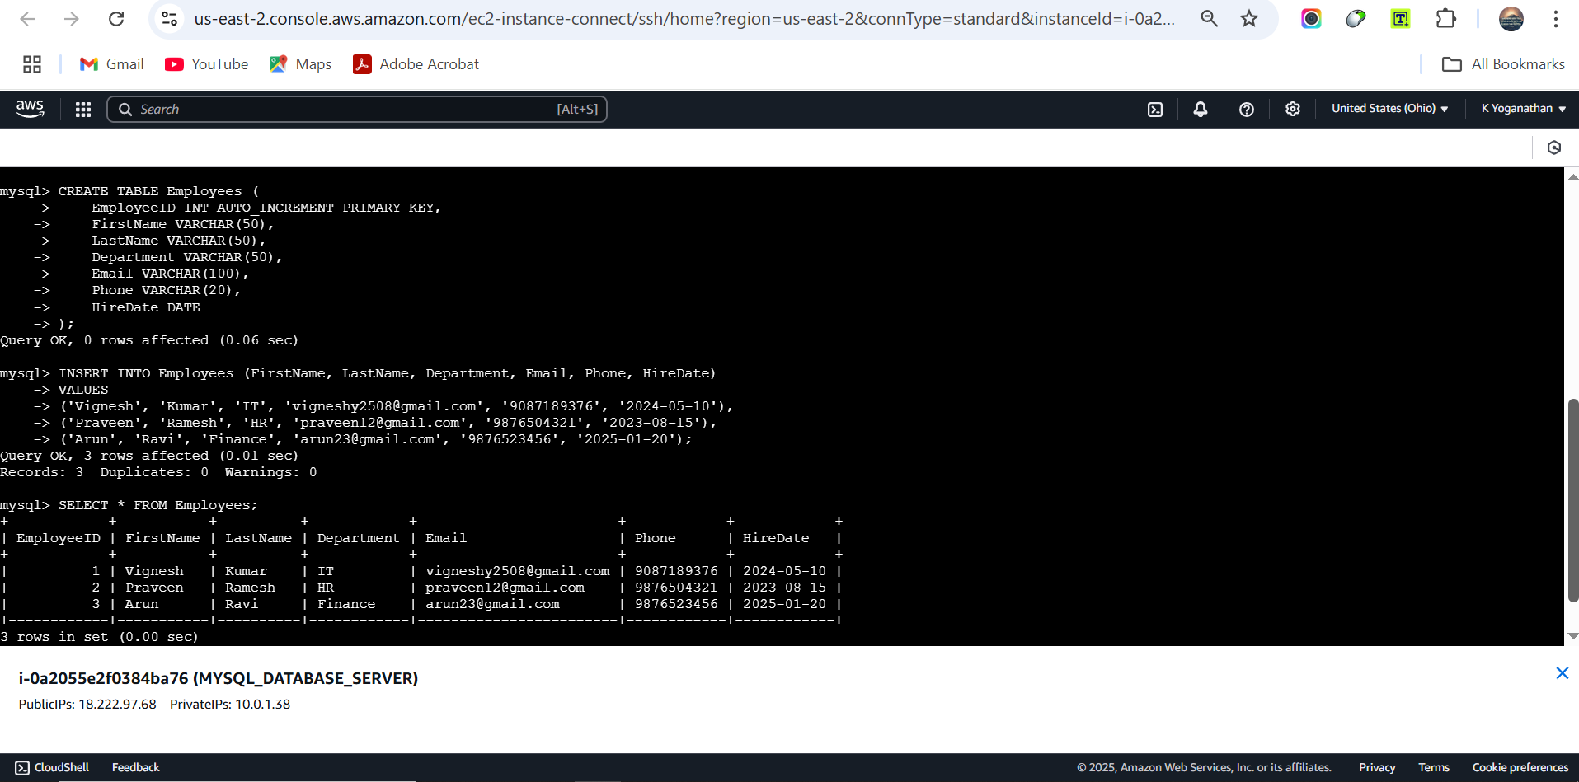

View Employee Records and Take a Backup of the Database
mysqldump -h <RDS-ENDPOINT> -u admin -p CompanyDB > CompanyDB_backup.sql

